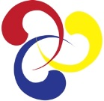
Korean Cultural Society of Boston
www.kcsBoston.org

KOREAN CULTURAL SOCIETY OF BOSTON presents
Korean-American Contemporary Artists
September 20 – October 5, 2014
Lexington Arts & Craft Society
130 Waltham St., Lexington, MA 02421

Korean Cultural Society of Boston (KCSB) presents its second exhibition by Korean-American contemporary artists in the Boston area. Over 30 art pieces, selected by Jane Portal, the Matsutaro Shoriki Chair, Art of Asia, Oceania, and Africa of MFA Boston, will be exhibited. The exhibition features pieces in a variety of media, including oil paint, photography, clay, and fabric. Sculptures by the invited artist, Peter Haines, will also be featured. The second art exhibition by KCSB runs from Sept. 20th to Oct. 5th at the Lexington Arts and Craft Society (130 Waltham St. Lexington, MA 02421). A reception will be held from 2-4 pm on Sept. 20th.
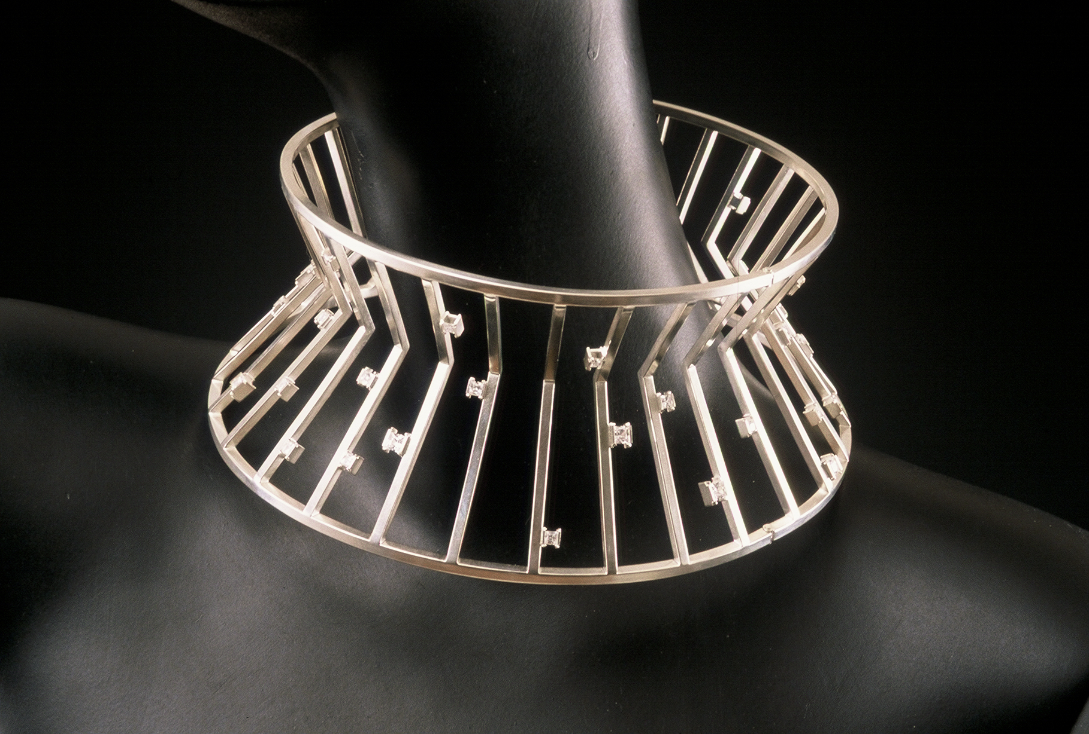
KCSB was founded two years ago and focuses on presenting Korean culture. Besides the exhibition, KCSB organizes concerts of traditional Korean music as well as classical music concerts. Future and past activities can be found at www.kcsBoston.org.
